## 

**Medical Clinic**

**Information Management System**

**DMIT 2028**

**Team S2: Da Hai (David) Wen**

**Na Wang**

**Prince Selhi**

**Nan Wang**

Table of Contents

Written Report 4

A. Purpose of report 4

B. Purpose of project 4

C. System (component) requirements (based on an agreed upon scope) 5

D. Stakeholder Analysis 6

Identify stakeholders and analyze their needs 6

E. Benefits to Stakeholders 8

F. Project risk analysis and feasibility 9

Identify the Project risks 9

Evaluate the probability and impact for each risk 9

Describe the risk management strategies you recommend for each risk 10

For each strategy described, list the risk management category to which it belongs: accept, avoid, or mitigate 11

G. Summary and Recommendations 11

Key results of requirement gathering 11

Benefits of developing the project 12

Recommendations 12

Diagrams and models 13

USE CASE DIAGRAM 13

DOMAIN MODEL CLASS DIAGRAM 14

ENTITY RELATIONSHIP DIAGRAM 15

User Interface for Register Patient 16

Use Case Template for Registering Patient 16

Sequence Diagrams for Registering Patient 17

Use Case Template for Lookup Patient 18

Sequence Diagrams for LookUp Patient 18

Use Case Template for Book Appointment 19

Sequence Diagrams for Book Appointment 20

Use Case Template for Book Exam Room 21

Sequence Diagrams for Book Exam Room 22

User Interface for Create Treatment Plan 23

Use Case Template for Create Treatment Plan 23

Sequence Diagrams for Create Treatment Plan 24

Use Case Template for Add Procedure 25

Sequence Diagrams for Add Treatment Procedure 26

Use Case Template for Update Treatment Plan 27

Sequence Diagrams for Update Treatment Plan 28

User Interface for Purchase Order For Inventory 29

Use Case Template for Create Purchase Order for Inventory 29

Sequence Diagrams for Create Purchase Order 30

Use Case Template for Update Inventory 31

Sequence Diagrams for Update Inventory 32

Use Case Template for Register Student 32

Sequence Diagrams for Registering Student 33

Use Case Template for Schedule student in class 33

Sequence Diagrams for Schedule Student In Class 34

User Interface for Inventory Report 35

User Interface for Monthly Clinic Appointment and Treatment Profit Report 36

STATE DIAGRAMS 37

State Diagrams for Create Treatment Plan 37

State Diagrams for Create Order 38

Gantt chart 39

# Written Report

## Purpose of report

The purpose of this report is to analyze our product which is NAIT Clinic Information Management Information System, and recommend a suitable business process to improve clinic growing, and a suitable training process to help the manager to enroll the students in training courses. Moreover, the system provides many different information for patient, and will track the scheduling, patient flow, and patient account.

This report will also discuss how main audiences (clerks, instructors, students, and managers) operate this system and it will analyze the system and provide some recommendations.

This report will analyze the system and provide some recommendations.

1. The report will show how this system stores and processes data
2. This report will show the system requirements for business process and training process
3. The analysis of report will include the benefits and risks of stakeholders
4. A summary and recommendations will be provided for the client

## Purpose of project

Our product is NAIT Clinic Information Management Information System which is developed to improve the clinic management and the efficiency of working ability. By using NAIT Clinic Information Management Information System, there are some main benefits in the following:

1. This system has different levels of accessibility for different category of users
2. The system is easy to use for all clients
3. The system provides data fix function which could reduce the stress of users
4. The system contains both business process and training process
5. For business process:
6. The system will store and process data from patients
7. Clerks can operate this system to book schedules, and deal with inventory
8. Instructors deal with treatment plans
9. The procedures can be added when the manager or doctors when they think if necessary based on the data collection
10. For training process:
11. Students can register themselves
12. The manager will enroll the students into courses

## System (component) requirements (based on an agreed upon scope)

Based on the analysis of the NAIT Emergency Medicine and Care Clinic Process, we will create the NAIT Clinic Information Management Information System.

Purpose of System requirements:

There are two major purposes for the NAIT Clinic Information Management Information System. One purpose is to meet the growing of the business, and another is to help NAIT students to gain hands-on-experience as the training purpose. Therefore, the intended audiences include clerks, instructors, students, and managers.

For business purpose:

For daily operations, clerks use the system to search clients, register patients’ information, and book appointments for the patients (also suitable for walk-in patients when they register in clinic). In addition, by using this system, clerks can book exam rooms, update patient’s appointment schedules, create purchase order for inventory, and update inventory.

Instructors also can use this system to create or update treatment plans.

The manager of the clinic can use this system to add procedure for treatment when they think the current procedures are not good enough for the clinic (such as add another X-ray, MRI).

For training purpose:

Students use the system to register themselves, and the manager uses this system to schedule classes for students.

Security:

This system stores information from patients and students, and used by multiple

Users. Therefore, we provide different levels of accessibility for different category of users.

1. Clerks can only register patient’s information, book schedules, and deal with inventory.
2. Instructors can only create and update treatment plans.
3. Students can only register themselves, can view their class schedules and marks.
4. Managers have access to view all the information in the system.
5. System administrators could be able to view and modify information in the system, including the database as the back end, and also the ability to maintain the user interface.

## Stakeholder Analysis

The purpose of this analysis is to guild the process of developing the system for **NAIT Emergency Medicine and Care Clinic**.This allows stakeholders to view the relationship to others and better communication on concerns.

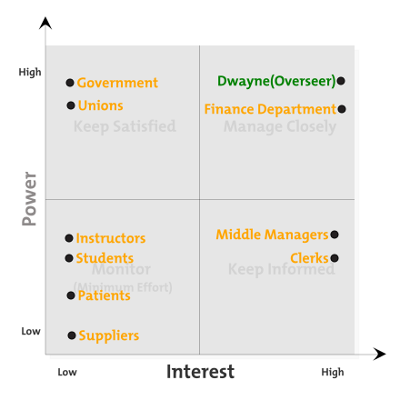

### Identify stakeholders and analyze their needs

|  |  |  |
| --- | --- | --- |
| **Stakeholder** | **Needs/Interests** | **Attitude** |
| Dwayne(Overseer) | 1. Train students in a professional medical environment 2. Treat patients to train students 3. Add treatment procedures 4. Schedule students in classes 5. Deal with policies, unions and government 6. Make profits | Supportive. |
| Finance Department | 1. Financial well balance 2. Long-term benefits | Neutral |
| Government | 1. Political good looking 2. Students get well trained 3. Patients get well treated |  |
| Unions | 1. Members’ rights and benefits 2. Improved working conditions 3. Payment on time. 4. Appropriate supplies in facilities |  |
| Middle Managers | 1. New system easy to use 2. Co-ordinate staffs’ schedule |  |
| Clerk | 1. New system easy to learn 2. New system easy to use 3. Improved working conditions 4. Register patient 5. Book appointment 6. Book exam room 7. Update schedules 8. Create inventory purchase orders 9. Update inventory | Neutral |
| Instructor | 1. New system easy to use 2. Treat patients 3. Train students 4. Create treatment plans | Neutral |
| Student | 1. New system easy to use 2. Register 3. Get trained 4. Graduate | Neutral |
| Patient | 1. Get treated | Neutral |
| Supplier | 1. Increase sells | Neutral |

## E. Benefits to Stakeholders

The key benefits to all stakeholder is to meet part of their needs/interests. Here is how each group will benefit:

|  |  |
| --- | --- |
| **Stakeholder** | **Benefit** |
| Dwayne(Overseer) | 1. Train students in a professional medical environment 2. An independent system all to the man himself 3. More decision-making power 4. Make profits |
| Finance Department | 1. More income from both treating patients and training students. |
| Government | 1. Political good looking 2. More tax income. |
| Unions | 1. Appropriate supplies in facilities |
| Middle Managers | 1. New system easy to use |
| Clerk | 1. New system easy to use 2. Participation in process |
| Instructor | 1. New system easy to use 2. Treating patient and training students, possible incentives on increased salary |
| Student | 1. New system easy to use 2. Get trained in a professional medical environment |
| Patient | 1. Get treated more efficiently. |
| Supplier | 1. Increase sells and publicity due to our system treat patients and train students. |

## F. Project risk analysis and feasibility

### Identify the Project risks

|  |  |
| --- | --- |
| **Risk count** | **Identify** |
| 1 | Register incorrect information of patients |
| 2 | This system cannot be used when no internet connection |
| 3 | Clerks and instructors hard to use this system |
| 4 | The privileges of System administrator |
| 5 | The system cannot be used during a power outage |
| 6 | The security of database |
| 7 | The clinic changes the scope of software design |

### Evaluate the probability and impact for each risk

|  |  |  |  |
| --- | --- | --- | --- |
| **Risk count** | **Identify** | **Probability** | **Impact** |
| 1 | Register incorrect information of patients | 7 | 2 |
| 2 | This system cannot be used when no internet connection | 2 | 10 |
| 3 | Clerks and instructors hard to use this system | 3 | 3 |
| 4 | The privileges of System administrator | 4 | 4 |
| 5 | The system cannot be used during a power outage | 1 | 10 |
| 6 | The security of database | 3 | 10 |
| 7 | The clinic changes the scope of software design | 5 | 8 |

### Describe the risk management strategies you recommend for each risk

1. Register incorrect information of patients

This situation happens quit often, and the impact is not significant because we provide data fix ability.

1. This system cannot be used when no internet connection

The probability of this situation is a low level, but the impact is huge. Therefore, the clinic should fix this problem immediately as soon as possible. Clerks should know the internet technical support information who provide 24/7 services.

1. Clerks and instructors hard to use this system

Using this system, Clerks and instructors are the main users. They should know how to deal with this system. To help them to learn, we will provide a three days training session for them.

1. The privileges of System administrator

The System administrator can view and modify everything in this system. When they made any mistakes, the impact is huge. The best solution is database backup every day (2 am).

1. The system cannot be used during a power outage

The probability of this situation is a very low level, but the impact is big. Therefore, the clinic should fix this problem immediately as soon as possible. Clerks should know the electricity support information who provide 24/7 services.

1. The security of database

This system stores information from patients and students, and the security of database is very important for the clinic. To keep the safety, the best way is hiring a database security administrator.

1. The clinic changes the scope of software design

The client may change the scope or purpose of the system during the projects. The impact is delay the releasement of the software, and sometimes the whole project will be changed. The best solution for this is to sign a contract to declare the responsibility and the rights for both. If the clinic decides to change something, then we need to discuss the contract and the additional payment.

### For each strategy described, list the risk management category to which it belongs: accept, avoid, or mitigate



## G. Summary and Recommendations

### Key results of requirement gathering

Dwayne wants to have a system that can train NAIT’s student in a professional medical environment. Here are the key results of requirement gathering.

1. The system is independent
2. The system will train students in a hands-on medical environment
3. The system will register students
4. The system will register patients
5. The system will help doctors (instructors) to diagnose patients by booking them with various exams (blood, x-ray, etc.)
6. The system will assist instructors to create treatment plans for patients
7. The system will assist Dwayne can add new treatment procedures (e.g. MRI) to his clinic
8. The system will assist clerks and managers to manage the clinic’s inventory

### Benefits of developing the project

The NAIT Clinic Information Management Information System will improve the clinic management and the efficiency of working ability. Dwayne gets increased power and leadership by having an independent system to NAIT Emergency Medicine and Care Clinic. The system has various features as mentioned above to full-fill Dwayne’s purpose of training students in a professional medical environment and providing hands-on experience. The system will help Dwayne to profit both politically and financially by treating patients and training students simultaneously.

### Recommendations

* Our system increase the working efficiency.
* Reduced manual procedures to reduce human errors.
* We also provide data fix.
* We recommend to implement software solution based on the system in this report.

# Diagrams and models

### USE CASE DIAGRAM



### DOMAIN MODEL CLASS DIAGRAM



### ENTITY RELATIONSHIP DIAGRAM



### User Interface for Register Patient

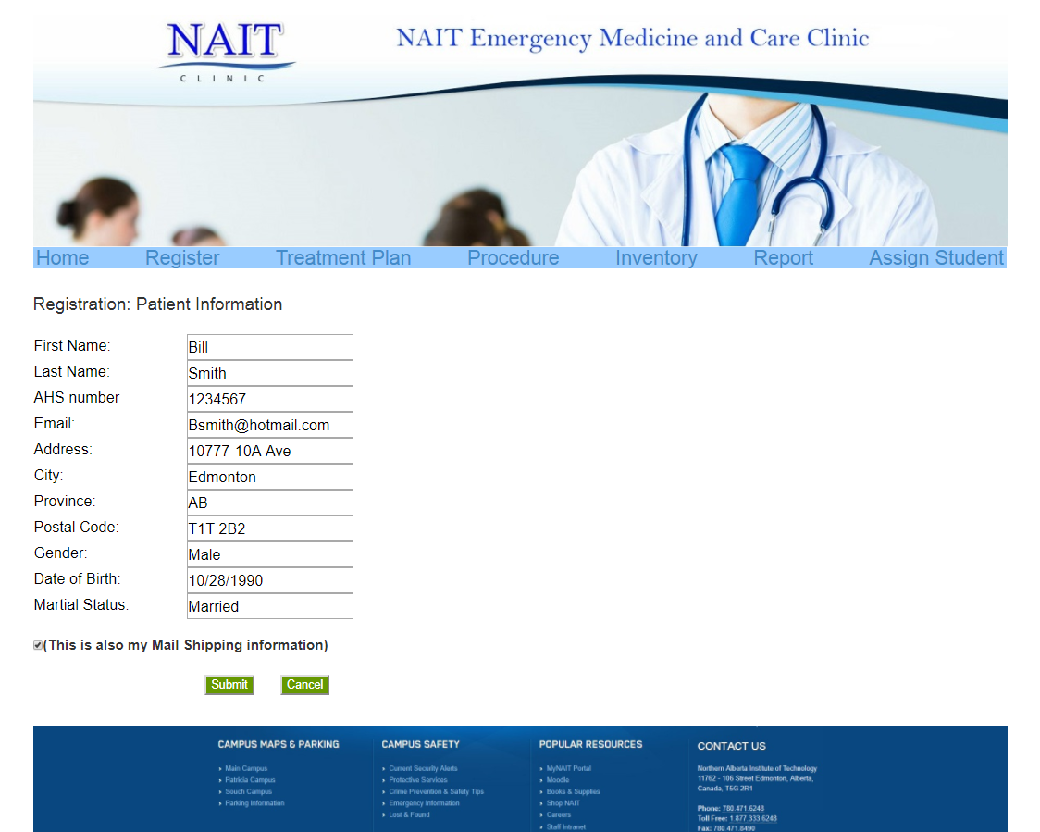

### Use Case Template for Registering Patient

|  |  |  |
| --- | --- | --- |
| **Use Case Name:** | *Register Patient* | |
| **Description:** | *Clerk registering in the system* | |
| **Actor(s):** | *Clerk* | |
| **Preconditions:** | *Patient file does not exist* | |
| **Trigger:** |  | |
| **Normal flow of events:** | **Actor action** | **System Response** |
| *1)AddPatient(lastName, firstName, gender, dateOfBirth, placeOfBirth, placeOfResidence, phoneNumber, postcode, HealthCardNumber)* | *2) Return patientID* |
| **Post-conditions:** | *Patient file exist* | |

### Sequence Diagrams for Registering Patient



### Use Case Template for Lookup Patient

|  |  |  |
| --- | --- | --- |
| **Use Case Name:** | *Lookup Patient* | |
| **Description:** | *Actors lookup Patient* | |
| **Actor(s):** | *Clerk, Instructor* | |
| **Preconditions:** | *Patient file exists* | |
| **Trigger:** |  | |
| **Normal flow of events:** | **Actor action** | **System Response** |
| 1. *LookUPaitent (firstName, lastName,* *HealthCardNumber)* | 1. *return patient[]* |

### Sequence Diagrams for LookUp Patient



### Use Case Template for Book Appointment

|  |  |  |
| --- | --- | --- |
| **Use Case Name:** | *Book Appointment* | |
| **Description:** | *Clerk creates appointment for patient* | |
| **Actor(s):** | *Clerk* | |
| **Preconditions:** | *Patient file exists* | |
| **Trigger:** |  | |
| **Normal flow of events:** | **Actor action** | **System Response** |
| 1. *Call LookUpPatient ()* 2. *Lookup ExamRoomSchedule(Date, time)*   *4)Creat Appointment(Date, time, patientID, ExamRoomScheduleID, reasonOfVisit)* | 1. *Return ExamRoomSchedule[]*   *5)return AppointmentID* |
| **Post-conditions:** | *Appointment exist* | |

### Sequence Diagrams for Book Appointment



### Use Case Template for Book Exam Room

|  |  |  |
| --- | --- | --- |
| **Use Case Name:** | *Book Exam Room* | |
| **Description:** | *Clerk book exam room* | |
| **Actor(s):** | *Clerk* | |
| **Preconditions:** | *Appointment exist* | |
| **Normal flow of events:** | **Actor action** | **System Response** |
| *1)LookUpAppointment (Date,time,PatientID)*  *3)Look up examRoom (RoomType)*  *5)Update examRoomSchedule (AppointmentID, time)* | *2)return Appointment[]*  *4)Return examRoomSchedule []*  *6)Return examRoomSchedule Updated* |
| **Post-conditions:** | *examRoomSchedule updated* | |

### Sequence Diagrams for Book Exam Room



### User Interface for Create Treatment Plan

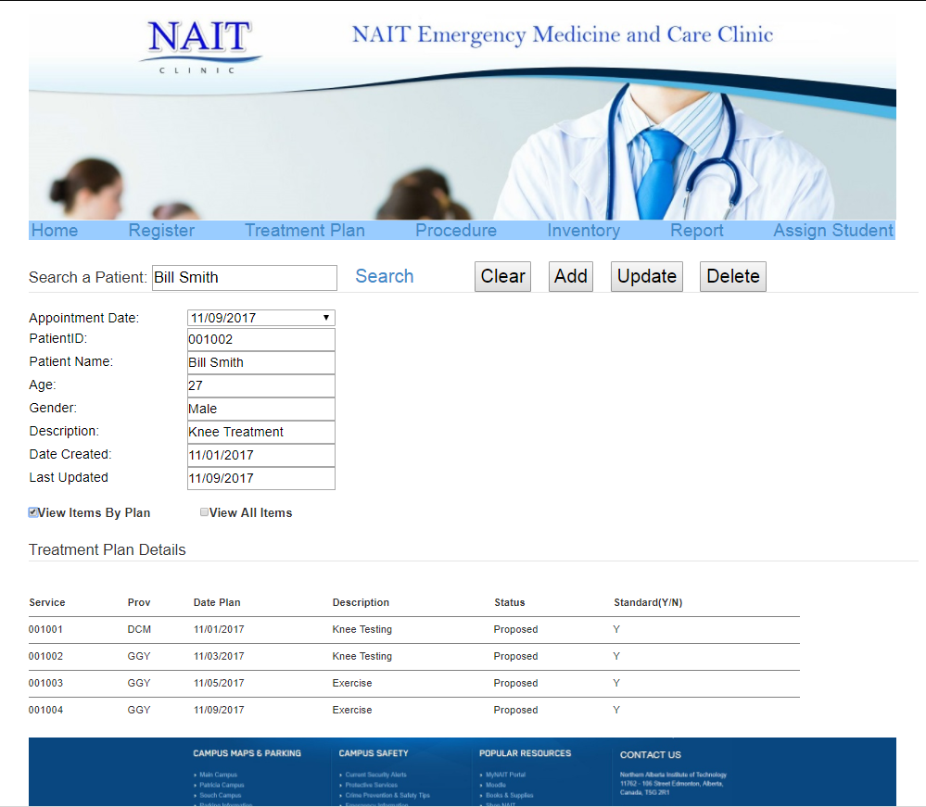

### Use Case Template for Create Treatment Plan

|  |  |  |
| --- | --- | --- |
| **Use Case Name:** | *Create Treatment Plan* | |
| **Description:** | *Instructor create treatment plan for patient* | |
| **Actor(s):** | *NursingInstructor* | |
| **Preconditions:** | *Appointment exist, NursingInstructor exist, Treatment plan does not exist* | |
| **Trigger:** |  | |
| **Normal flow of events:** | **Actor action** | **System Response** |
| *1)Call LookUpPatient()*  *2)Lookup Appointment(PatientID)*  *4)createTreatmentPlan(AppointmentID,*  *patientID, date,time, Description ,* NursingInstructorID*)* | *3)Return Appointment[]*  *5)AddTreatmentPlan (AppointmentID,*  *patientID, date,time, Description ,* NursingInstructorID*)*  *6)ReturnTreatmentPlanID* |
| **Post-conditions:** | *Patient Treatment plan exist* | |

### Sequence Diagrams for Create Treatment Plan



### Use Case Template for Add Procedure

|  |  |  |  |
| --- | --- | --- | --- |
| **Use Case Name:** | *Add Procedure* | |  |
| **Description:** | *Nursing Instructor add procedures to the treatment plan* | |  |
| **Actor(s):** | *Nursing Instructor* | |  |
| **Preconditions:** | *treatment Plan exist* | |  |
| **Trigger:** |  | |  |
| **Normal flow of events:** | **Actor action** | **System Response** |  |
| *1) lookup ExamProcedure(name)*  *3) lookup TreatmentProcedure(name)*  *5) lookup Inventory(name)*  *7)CreateTreatmentPlantDetails(ExamProcedureID, TreatmentProcedureID, InventoryID, description)* | *2) Return ExamProcedure[]*  *4) Return TreatmentProcedure[]*  *6)Return Inventory[]*  *8)Add TreatmentPlantDetails(ExamProcedureID, TreatmentProcedureID, InventoryID, description)*  *9)Return TreatmentPlantDetailsID* |  |
| **Post-conditions:** | *procedure exist* | |  |

### Sequence Diagrams for Add Treatment Procedure



### Use Case Template for Update Treatment Plan

|  |  |  |
| --- | --- | --- |
| **Use Case Name:** | *Update Treatment Plan* | |
| **Description:** | *Nursing Instructor update treatment plan* | |
| **Actor(s):** | *NursingInstructor* | |
| **Preconditions:** | *Treatment Plan exist* | |
| **Normal flow of events:** | **Actor action** | **System Response** |
| 1. *Call LookupPatient()* 2. *LookUpAppointment (PatientID)*   *3)Lookup treatmentPlan (AppointmentID)*  *5)update treatment plan(AppointmentID,*  *patientID, date,time, Description ,* NursingInstructorID*)* | *4)return treatmentPlan[]*  *6)update treatment (AppointmentID,*  *patientID, date,time, Description ,* NursingInstructorID*)*   1. *Return confirmation* |
| **Post-conditions:** | *Patient treatment plan updated* | |

### Sequence Diagrams for Update Treatment Plan



### User Interface for Purchase Order For Inventory

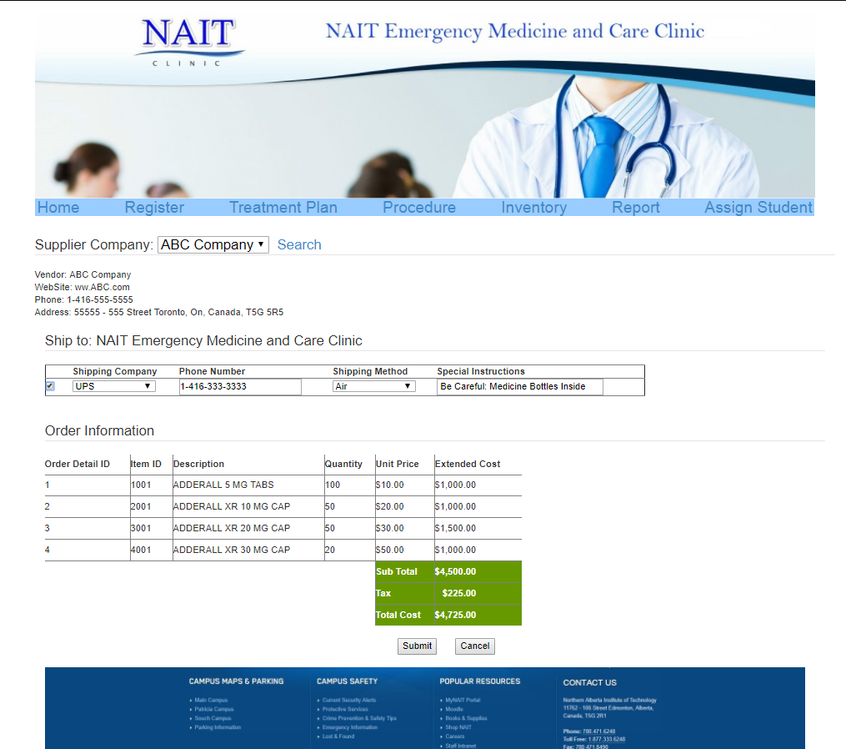

### Use Case Template for Create Purchase Order for Inventory

|  |  |  |
| --- | --- | --- |
| **Use Case Name:** | *Create Purchase Order for Inventory* | |
| **Description:** | *Clerk Creates Purchase Order for Inventory* | |
| **Actor(s):** | *Clerk* | |
| **Preconditions:** | *Purchase Order does not exist* | |
| **Trigger:** |  | |
| **Normal flow of events:** | **Actor action** | **System Response** |
| *1)Create purchaseOrder(supplierID, companyName, InventoryID, quantity, UnitPrice, date, subtotal,Total, Description, Remark)* | *2)Add purchaseOrderDetails(inventoryID, quantity, unitPrice, description)*  *3)Return purchaseOrderID* |
| **Post-conditions:** | *Purchase Order exists* | |

### Sequence Diagrams for Create Purchase Order



### Use Case Template for Update Inventory

|  |  |  |
| --- | --- | --- |
| **Use Case Name:** | *Update Inventory* | |
| **Description:** | *Clerk Updates Inventory* | |
| **Actor(s):** | *Clerk* | |
| **Preconditions:** | *Inventory exist* | |
| **Trigger:** |  | |
| **Normal flow of events:** | **Actor action** | **System Response** |
| *1)LookUp Inventory (Name)*  *3)Update Inventory (QuantityOnHand)* | *2)Return Inventory[]*  *4)Return confirmation* |

### Sequence Diagrams for Update Inventory



### Use Case Template for Register Student

|  |  |  |
| --- | --- | --- |
| **Use Case Name:** | *Register Student* | |
| **Description:** | *Student registering in the system* | |
| **Actor(s):** | *Student* | |
| **Preconditions:** | *student does not exist* | |
| **Trigger:** |  | |
| **Normal flow of events:** | **Actor action** | **System Response** |
| *1)Create student(lastName, firstName, gender, Address, postcode, Email)* | *2) Return StudentID* |
| **Post-conditions:** | *student exists* | |

### Sequence Diagrams for Registering Student



### Use Case Template for Schedule student in class

|  |  |  |
| --- | --- | --- |
| **Use Case Name:** | *Schedule student in class* | |
| **Description:** | *Dwayne signs students in a class* | |
| **Actor(s):** | *Dwayne* | |
| **Preconditions:** | *student is not in the class* | |
| **Trigger:** |  | |
| **Normal flow of events:** | **Actor action** | **System Response** |
| *1)lookup student(name)*  *3)Lookup Course(name)*  *5) create Enrollment(StudentID, courseID, mark)* | *2)Return student[]*  *4)Return Course[]*  *6)Return EnrollmentID* |
| **Post-conditions:** | *student is in the class* | |

### Sequence Diagrams for Schedule Student In Class



### User Interface for Inventory Report

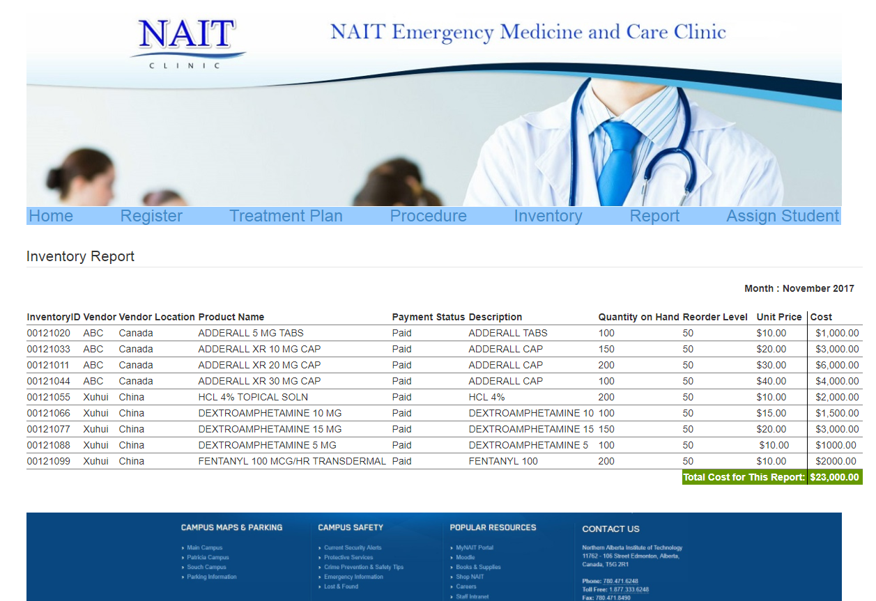

### User Interface for Monthly Clinic Appointment and Treatment Profit Report

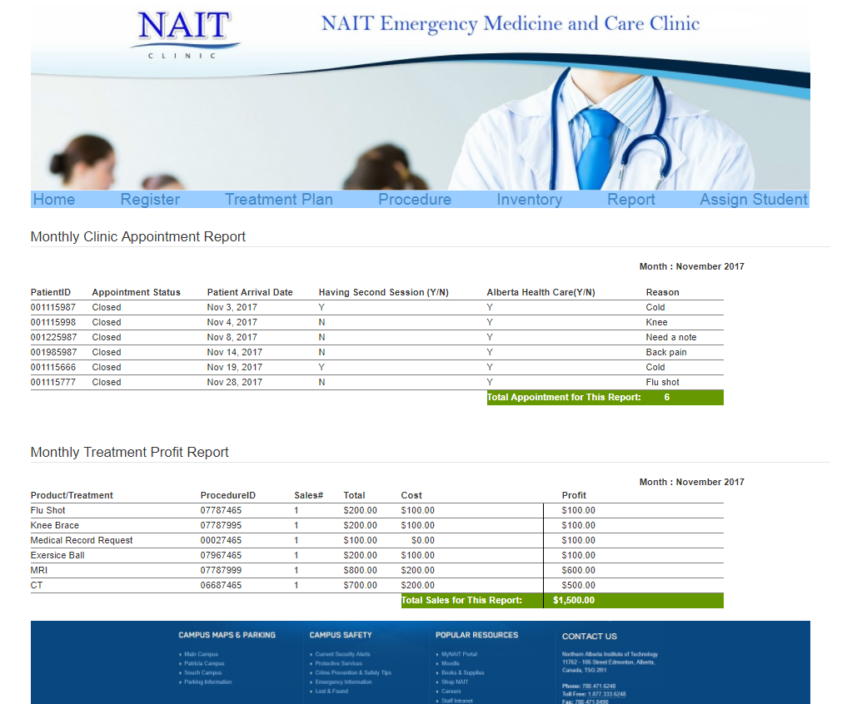

# STATE DIAGRAMS

### State Diagrams for Create Treatment Plan



### State Diagrams for Create Order



# Gantt chart

